Ideation Phase

Define the Problem Statements

|  |  |
| --- | --- |
| Date | 19 September 2022 |
| Team ID | PNT2022TMID17703 |
| Project Name | Project - A NOVEL METHOD FOR HANDWRITTEN DIGIT RECOGNITION SYSTEM |
| Maximum Marks | 2 Marks |

Problem Statement 1

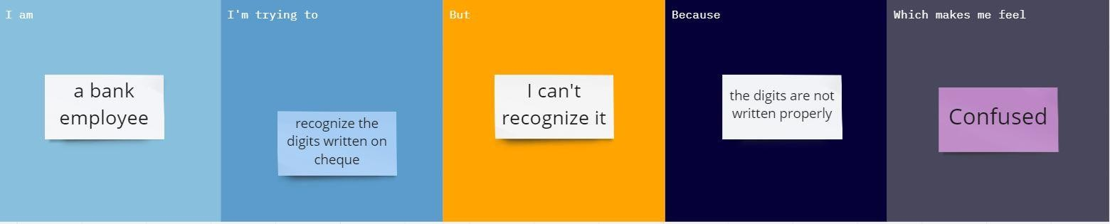

Problem Statement 2

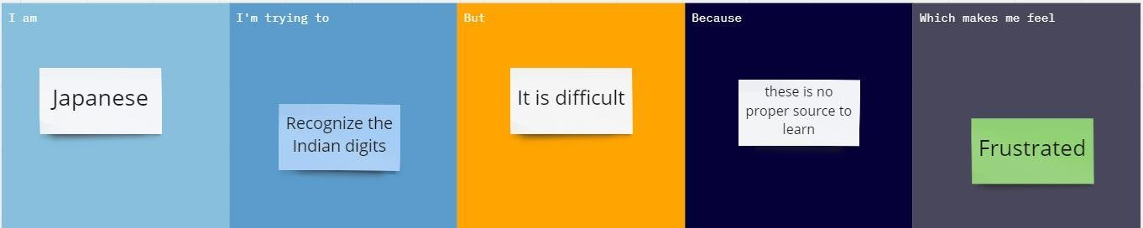

Problem Statement 3

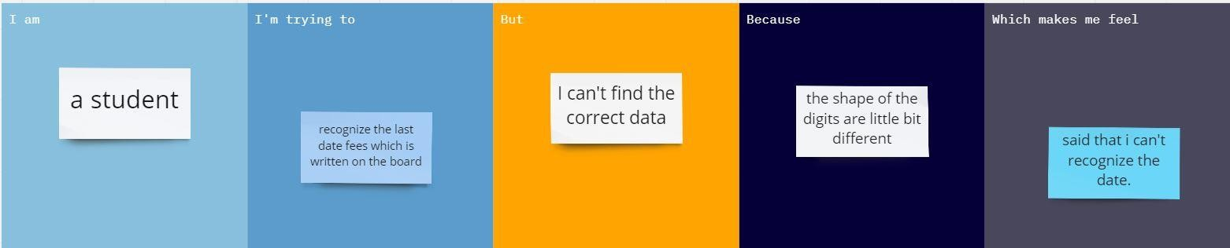

Problem Statement 4

